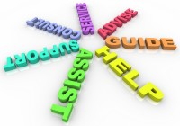

**Counselor’s Corner**

Mrs. Dougherty ~ April 2020

**We Care About You**

Cold Water Family, we miss you! We want to thank you all for your patience, understanding, cooperation, and support during this new way of learning. Even though we are at home we are still with you and here to support you however we can.

Please be sure to utilize the Hazelwood website, Cold Water website, and email to see the latest updates about curriculum, food services, and timelines.

A lot of information has been coming your way. If you are feeling overwhelmed or do not know where to start with it all please contact your child's teacher, Mr. Dix, or myself. We are here to help.

**The Zones of Regulation**

The Zones of Regulation can be a support and a sense of normalcy for your children at this time. All students are taught this language and frequently use it throughout the day at school. Here is a recap of the ZoR. I am sure your children can teach you even more and demonstrate how the use their skills/tools to get back in the green zone!

The **Zones of Regulation** is a curriculum that helps students gain skills in regulating their actions, which leads to increased control and problem solving abilities. The Zones is a cognitive behavioral approach used to teach self-regulation by labeling all of our different emotions and how our bodies feel into four specific colored zones. The Zones structure provides strategies to teach students to become more aware of and independent in controlling their emotions and impulses, manage their sensory needs, and improve their ability to problem solve conflicts.

**THE FOUR ZONES: OUR FEELINGS & STATES DETERMINE OUR ZONE**

The **Red Zone** is used to describe extremely heightened states of alertness and intense emotions. A person may be elated or experiencing anger, rage, explosive behavior, devastation, or terror when in the Red Zone.   
The **Yellow Zone** is also used to describe a heightened state of alertness and elevated emotions, however one has more control when they are in the Yellow Zone. A person may be experiencing stress, frustration, anxiety, excitement, silliness, the wiggles, or nervousness when in the Yellow Zone.

The **Green Zone** is used to describe a calm state of alertness. A person may be described as happy, focused, content, or ready to learn when in the Green Zone. This is the zone where optimal learning occurs.   
  
The **Blue Zone** is used to describe low states of alertness and down feelings such as when one feels sad, tired, sick, or bored.

The Zones can be compared to traffic signs. When given a green light or in the Green Zone, one is “good to go”. A yellow sign means be aware or take caution, which applies to the Yellow Zone. A red light or stop sign means stop, and when one is the Red Zone this often is the case. The Blue Zone can be compared to the rest area signs where one goes to rest or re-energize. All of the zones are natural to experience, but the framework focuses on teaching students how to recognize and manage their Zone based on the environment and its demands and the people around them.

Students may want to create a Zones of Regulation Peace Place in the house. This gives them a place with tools they can use to help when they are feeling stressed, angry, sad, scared, etc.

INTERNET SAFETY TIPS FOR CHILDREN & TEENS

With virtual learning taking place and an increase in screen time during our social distancing, I wanted to remind you of some safety tips Mrs. Hamilton shared with us last year.

Information is from the following site: <https://www.nypl.org/help/about-nypl/legal-notices/internet-safety-tips>

· **Personal Information**. Don’t give out personal information without your parents’ permission. This means you should not share your last name, home address, school name, or telephone number. Remember, just because someone asks for information about you does not mean you have to tell them anything about yourself!

· **Screen Name**. When creating your screen name, do not include personal information like your last name or date of birth.

· **Passwords**. Don’t share your password with anyone but your parents. When you use a public computer make sure you logout of the accounts you’ve accessed before leaving the terminal.

· **Photos**. Don’t post photos or videos online without getting your parents’ permission.

**Online Friends**. Don’t agree to meet an online friend unless you have your parents’ permission. Unfortunately, sometimes people pretend to be people they aren't. Remember that not everything you read online is true.

· **Online Ads**. Don’t buy anything online without talking to your parents first. Some ads may try to trick you by offering free things or telling you that you have won something as a way of collecting your personal information.

· **Downloading**. Talk to your parents before you open an email attachment or download software. Attachments sometimes contain viruses. Never open an attachment from someone you don’t know.

· **Bullying**. Don’t send or respond to mean or insulting messages. Tell your parents if you receive one. If something happens online that makes you feel uncomfortable, talk to your parents or to a teacher at school.

· **Social Networking**. Many social networking websites (e.g., Facebook, Twitter, Second Life and MySpace) and blog hosting websites have minimum age requirements to sign up. These requirements are there to protect you!

· **Research**. Talk to your librarian, teacher or parent about safe and accurate websites for research. The public library offers lots of resources. If you use online information in a school project make sure you explain where you got the information.

For more tips, please see the following PDF: [http://www.safekids.com/kidsrules.htm](https://d140u095r09w96.cloudfront.net/sites/default/files/safekidslist.pdf).

Z.Hamilton, MSW

HSD Elementary School Social Worker

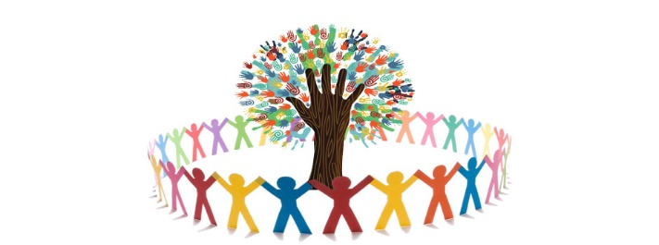

**Community Resources and Support**

A local social service agency, The Foster & Adoptive Care Coalition, has put together a list of several different resources both in the St. Louis area and online to help individuals and families address immediate needs during this time. This list includes resources that can assist with financial concerns, home education, keeping kids busy, mental health practices, access to food, self-care, etc.

<https://www.foster-adopt.org/resource-roundup/>

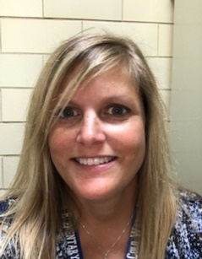

**Connie Dougherty**

**Professional School Counselor**

Phone: 314-953-4158

Email: [cdoghrty@hazelwoodschools.org](mailto:cdoghrty@hazelwoodschools.org)

[Cite your source here.]